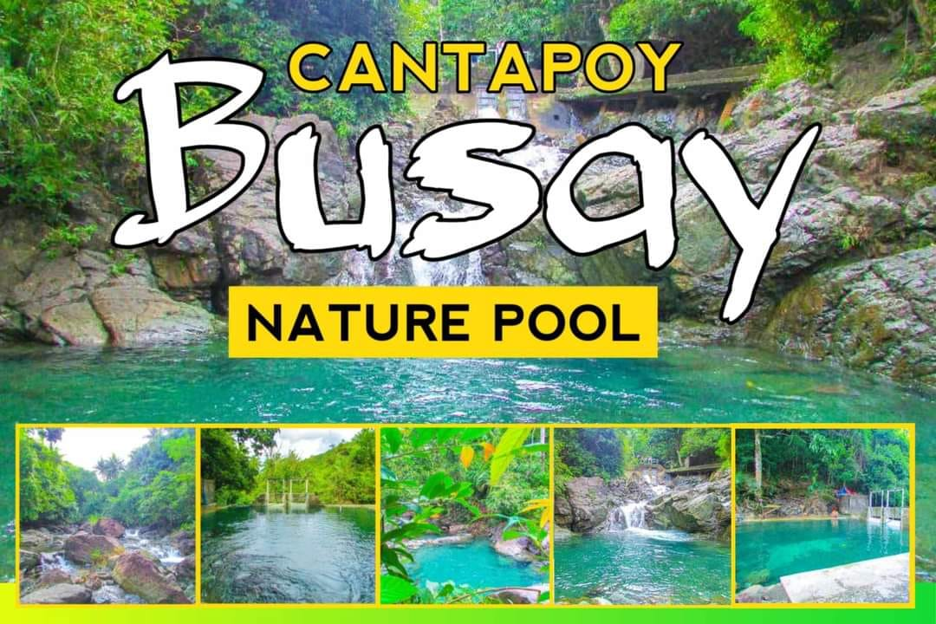

**FEES**

**Location**

**Activities**

**Foods & Drinks**

**Amazed to the Beauty of CANTAPOY, MALIMONO, SDN**

**“BUSAY”**

Video

SUPPORTED BY :

Follow Us

Logo part

About Busay

FAQs

Terms & Conditions

Privacy Policy

Your Privacy Choices

Busay

Spend Time with Families, Friends & Love-Ones

Refresh

READ

READ

Nature

Amazed the Freshness of the Native Water

READ

READ